
Test Three
Teacher:

Mr Staffe

Mrs. Carter

_____Mr Bertram

_____Mr Roohi

_____Ms Cheng

Semester One 2016
Year 12 Mathematics Methods
Calculator Free
Name:

- Complete all questions
- Show all necessary working
- Total Marks = 27
- 27 minutes

1. [6 marks]

Differentiate each of the following functions with respect to x. Do not simplify your answers.
- 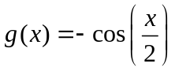 [2]

- 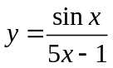 [2]

- 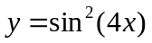 [2]

2. [4 marks]
Show, using the quotient rule, that 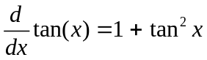 .

3. [9 marks]
Simplify or Evaluate the following integrals as appropriate
- 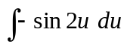 [3]

- 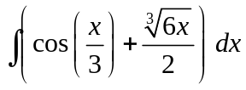 [3]

- 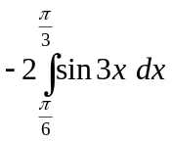 [3]
Evaluate

4. [8 marks]

- Simplify 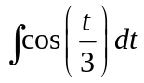 [2]

- Use your answer to part (a) to evaluate 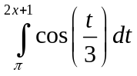, in terms of x [2]

- Use your answer to part (b) to evaluate 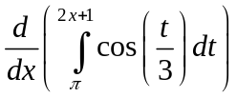 [2]

- Hence evaluate 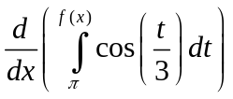 [2]

Teacher:

Mr Staffe

Mrs. Carter

_____Mr Bertram

_____Mr Roohi

_____Ms Cheng

Test Three

Semester One 2016
Year 12 Mathematics Methods
Calculator Assumed
Name:

- Complete all questions
- Show all necessary working
- Total Marks = 23
- 23 minutes

1. [ 6 marks ]

Determine, with reasoning, whether each of the following represent a discrete random variable.
(a)
x | 0 | 1 | 2 | 3 | 4
P(X=x) | 0.3 | 0.1 | 0.4 | 0.05 | 0.15

(b)
x | -2 | -1 | 1 | 3 | 5
P(X=x) | 0.2 | 0 | -0.3 | 0.6 | 0.5

(c) 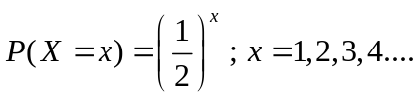

2. [8 marks]

Each of the following represent discrete probability functions. Determine the value of
k for each.

(a)
x | 0 | 1 | 2 | 3 | 4
P(X=x) | 0.2 | k | 0.3 | 0.1 | 0.15

[2]

(b) 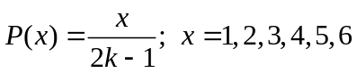 [3]

(c)
x | 1 | 2 | 3 | 5 | 7
P(X=x) | 2k | k | k | 5k | 6k

[3]

3. [9 marks]
Studies in Britain have recorded that 1 in 100 eight year-old children need at least one tooth removed caused by sugary drinks and severe tooth decay.
A typical primary school class of 24 eight year-olds are investigated for the need to remove at least one tooth.
Determine the probability of:
(a) 2 students needing at least one tooth removed. [1]

(b) No students requiring the removal of any teeth. [1]

(c) At least one student requiring the removal of at least one tooth. [2]

(d) Less than 4 students requiring the removal of at least one tooth given that at least one student required tooth removal. [2]

Of the thirteen year-olds in Britain requiring tooth removal, the probability of them requiring any one tooth out of their 32 permanent teeth removed, independent of the others is 5%.
(e) Calculate the probability of a permanent tooth in a thirteen year - old needing removal.
[3]

Test Three
Teacher:

Mr Staffe

Mrs. Carter

_____Mr Bertram

_____Mr Roohi

_____Ms Cheng

Semester One 2016
Year 12 Mathematics Methods
Calculator Free
Name: Mark King-Gyde

- Total Marks = 27
- 27 minutes

1. [6 marks]


Differentiate each of the following functions with respect to x. Do not simplify your answers.
- 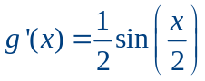
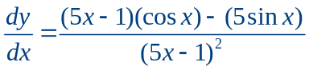
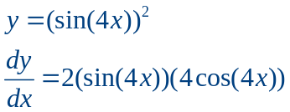
2. [4 marks]
Show, using the quotient rule, that .
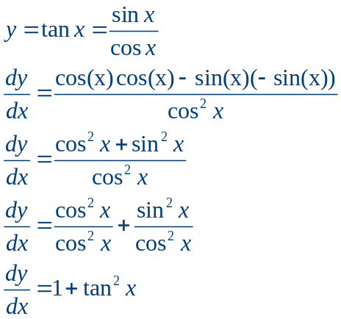

3. [9 marks]
Simplify or Evaluate the following integrals as appropriate
- 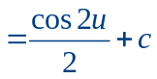
- 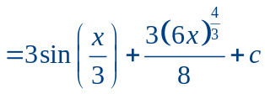
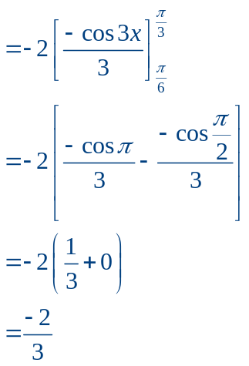

4. [8 marks]

- Calculate
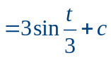
- Use your answer to part (a) to evaluate , in terms of x
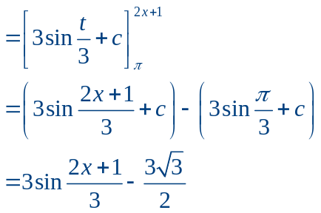
- Use your answer to part (b) to evaluate
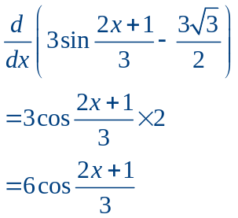
- Hence evaluate
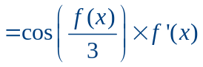

Teacher:

Mr Staffe

Mrs. Carter

_____Mr Bertram

_____Mr Roohi

_____Ms Cheng

Test Three

Semester One 2016
Year 12 Mathematics Methods
Calculator Assumed
Name: Mark King-Gyde

- Complete all questions
- Show all necessary working
- Total Marks = 36
- 36 minutes

1. [ 6 marks ]

Determine, with reasoning, whether each of the following represent a discrete random variable.
(a)
x | 0 | 1 | 2 | 3 | 4
P(X=x) | 0.3 | 0.1 | 0.4 | 0.05 | 0.15

Yes this table does represent a DRV, all probabilities add to 1 and there are no negative
values.

(b)
x | -2 | -1 | 1 | 3 | 5
P(X=x) | 0.2 | 0 | -0.3 | 0.6 | 0.5

No, this table does not represent a DRV. Despite all the probability values adding to 1, as one is negative, this cannot represent a DRV.
(c)
The sequence of probabilities is: 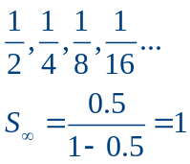
Therefore all probabilities will add to 1, and none are negative.

2. [8 marks]

(a)
x | 0 | 1 | 2 | 3 | 4
P(X=x) | 0.2 | k | 0.3 | 0.1 | 0.15

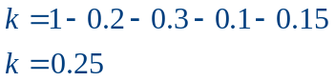

(b)
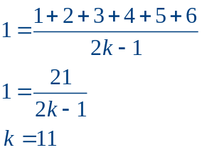

(c)
x | 1 | 2 | 3 | 5 | 7
P(X=x) | 2k | k | k | 5k | 6k

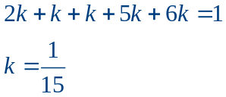

3. [9 marks]
Studies in Britain have recorded that 1 in 100 eight year-old children need at least one tooth removed caused by sugary drinks and severe tooth decay.
A typical primary school class of 24 eight year-olds are investigated for the need to remove at least one tooth.
Determine the probability of:
(a) 2 students needing at least one tooth removed.
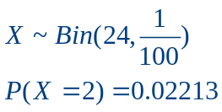
(b) No students requiring the removal of any teeth.
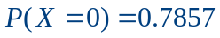
(c) At least one student requiring the removal of at least one tooth.
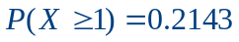

(d) Less than 4 students requiring the removal of at least one tooth given that at least one student required tooth removal.
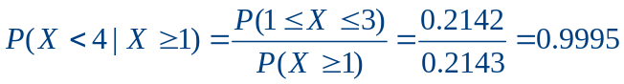
Of the thirteen year-olds in Britain requiring tooth removal, the probability of them requiring just one tooth out of their 32 permanent teeth removed is 5%.
(e) Calculate the probability of a permanent tooth in a thirteen year - old needing removal.
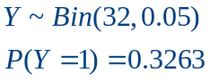

4. [13 marks]
Phoebe and Katelyn are facing a multiple choice assessment for their least favourite subject.
Marks for this test will be awarded in the following way: 4 marks will be awarded for a correct answer, 0 marks will be awarded for not attempting a question and 2 marks will be deducted for an incorrect answer.
This assessment contains 20 questions, each with four alternative answers.
Katelyn starts reading the test and is certain she knows 6 of the answers.
(a) If Katelyn attempts all questions, what is the chance she’ll answer 15 out of 20 correctly?
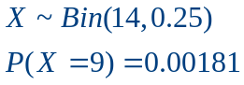
(b) If Katelyn attempts all questions, what is the most likely number of questions she’ll answer correctly?
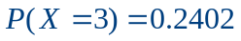
This is the highest probability in the above defined distribution.
Therefore Katelyn is most likely to guess three correctly. Hence she is likely to answer 9 questions correctly, with the 6 she already knows.
Phoebe starts reading the test and is certain she knows 10 of the answers.
She has two strategies to employ, detailed below.
Strategy A: Answer the 10 questions she knows for certain and guess the other 10.
Strategy B: Answer the 10 questions she knows for sure and guess 6 of the other 10 questions (thus not attempting 4 questions).
(c) Calculate the expected number of correct questions if Phoebe uses strategy A.
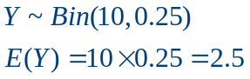
Phoebe is therefore expected to answer 12 or 13 answers correctly.
(d) Calculate the expected number of correct questions if Phoebe uses strategy B.
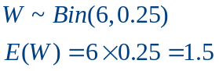
Phoebe is therefore expected to answer 11 or 12 answers correctly.

(e) Hence calculate the number of marks she can expect to be awarded with each strategy.
Strategy A: 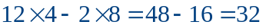 OR 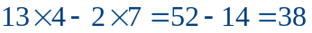
Strategy B: 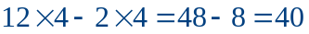 OR 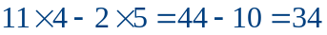

(f) Which strategy should Phoebe use?
Phoebe will earn more marks using Strategy B.

